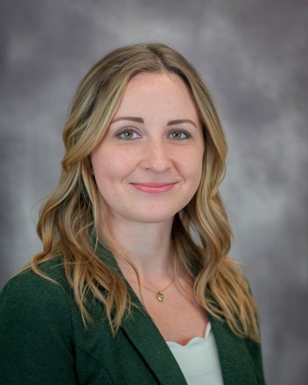

**Nora Fullington, MD, FACS**

Dr. Nora Fullington is a board-certified general surgeon specializing in minimally invasive ambulatory hernia and gallbladder surgery. She is a surgeon at Boston Hernia based in Wellesley, Massachusetts.

She is passionate about humanitarianism in medicine and has organized surgical mission trips to Haiti to treat the underserved population in Port au Prince and surrounding communities. She has also facilitated “Humanism in Medicine” lecture series. She has performed over 2,000 operations while working as a hospital based General Surgeon for several years and joined Boston Hernia in early 2021.

She obtained her Doctor of Medicine from New York Medical College. She also completed her General Surgery Residency at the University of Massachusetts and a Research Fellowship at Harvard Medical School and Children’s Hospital Boston. In addition, she has a Biology Degree from Providence College.

She is a national expert in hernia repair with lectures and publication of peer-reviewed studies on approaches to hernia repair and improvement in patient outcomes. When not working she enjoys time with her family, friends, and pets, travel, sports, hiking, biking, the ocean, almost all outdoor activities, and good conversation.